

Data Technician

Name: Alaa Mostafa
Course Date: 16/12/24
Table of contents
Day 1: Task 1 2
Day 2: Task 1 2
Day 2: Task 2 3
Day 2: Task 3 4
Day 3: Task 1 4
Day 3: Task 2 5
Dataset: 5
Step 1: Create a Pivot Table 5
Step 2: Use the SWITCH Function 5
Submission: 6
Day 3: Task 3 6
Day 4: Task 1 7
Course Notes 9
Additional Information 10

Day 1: Task 1

Please complete the below boxes on commons laws and regulations that must be followed when working with customers data, use the below bulleted list to support your answers.

- What is it
- Why is it important
- Provide a real-world example of how you can follow it
- How does it impact working with data
- What could happen if you breached it

Data Protection Act | What is it?  The Data Protection Act 2018 (DPA 2018) is the UK law that controls how personal data is collected, stored, used, and shared.  It applies to organisations that process personal data, such as:  Names, addresses, dates of birth, email addresses, medical records and criminal records.  The act ensures data is used lawfully and fairly and only collected for specific purposes.  Why is it important?  It is important because it protects an individual's rights over their personal data, this includes the right to access their data and correct anything that may be inaccurate. The individual may also have data erased in certain situations and / or know how their data is being used.  Organisations that follow the DPA build public trust and show accountability and professionalism.  Example: Handling service-user records  If you work at a council or NHS organisation and handle personal records you will need to follow the DPA. You would need to store personal data of service-users securely, use password protected systems and limit access only to people who need the data to do their job. To comply with the act, you would need to use encryption when sending sensitive data to colleagues and make sure you securely dispose of files when no longer needed.  How does it impact working with data?  It affects every stage of the data lifecycle. From collection, storage, usage and disposal.  When collecting data, only collect what is necessary and have a lawful basis, for example: consent and legal obligation. You must give a privacy notice i.e. tell individuals why their data is being collected.  Data must also be stored securely and protected against unauthorised access, loss or hacking. It should only be kept as long as necessary.  Data must only be used for the reason it was collected and cannot be shared without a legal reason. For example, sending personal data to the wrong email address is a data breach.  When disposing of data, you must make sure all digital files are deleted securely.  What could happen if you breached it?  If DPA is breached, legal consequences could follow. The Information Commissioner’s Office (ICO) can investigate the breach and issue enforcement notices. You could also be fined (up to £17.5 million or 4% of global turnover for serious breaches).  In an organisation, a breach may lead to a loss of public trust. The organisation may also receive attention from the media and suffer damage to its reputation.
GDPR | What is it?  The UK General Data Protection Regulation (UK GDPR) is a data protection law that sets out how personal data must be processed by organisations in the UK.  It applies to any organisation that collects or uses personal data, including public bodies, private companies, and charities.  GDPR sets out key principles for processing data, such as lawfulness, fairness, transparency, data minimisation, accuracy, storage limitation, and security.  Why is it important?  GDPR is important because it strengthens and standardises individuals’ rights over their personal data.  GDPR ensures organisations are accountable for how they handle personal data and encourages high standards of data protection, helping to build public trust.  Example: Handling job applicant data under GDPR  If you work in HR for a company or public authority, GDPR applies when handling job applications. When candidates apply for a job, they provide personal data such as names, contact details, CVs, qualifications, employment history and references. Applicants are given a privacy notice explaining how their data will be used and how long it will be kept, only data relevant to the job role will be collected.  How does it impact working with data?  It encourages ethical, secure and responsible data analysis and handling. You must:  - Check whether the data contains personal information  - Ensure data is accurate and up to date  - Limit who can access the data  - Avoid sharing data unnecessarily  - Anonymise data where possible  - Be careful when exporting, emailing, or presenting data  What could happen if you breached it?  There could be many consequences for breaching GDPR such as financial penalties, legal action, loss of customer trust, damage to reputation, disciplinary action for people involved and mandatory reporting to regulatory authorities.
Freedom of Information Act | What is it?  The Freedom of Information Act (FOIA) is a law that gives the public the right to request access to information held by public authorities.  Why is it important?  The Freedom of Information Act is important because it promotes transparency and accountability and Builds trust between public organisations and citizens. It also supports democracy by allowing scrutiny of public services.  Example: Local council data request  A member of the public can request information about how much a local council spends on road repairs. To follow the Freedom of Information Act, the council would:  - Check whether the information is held  - Respond within the legal time limit  - Provide the information unless an exemption applies  - Remove any personal or sensitive data before releasing it  How does it impact working with data?  When working with data, FOIA means data must be well organised, accurate and easy to retrieve. Data may need to be anonymised before release and staff must understand which data can and cannot be shared, also to whom it can be shared with.  What could happen if you breached it?  If breached, the Information Commissioner’s Office (ICO) could investigate, and you could be ordered to release the information. Public trust and reputation could be damaged, also.
Computer Misuse Act | What is it?  The Computer Misuse Act is a UK law that makes it illegal to access computer systems or data without permission, or to misuse systems in a way that causes harm. It covers offences such as Hacking into systems, accessing data without authorisation, spreading malware and disrupting or damaging systems.  Why is it important?  The Computer Misuse Act is important because it protects systems and data from unauthorised access and helps prevent cybercrime and data breaches.  Example: Workplace system access  An employee only accesses files and systems they are authorised to use and does not attempt to access colleagues’ accounts, bypass security controls or use admin privileges without permission. By respecting access permissions, the employee complies with this Computer Misuse Act.  How does it impact working with data?  When working with data this law means you must only access what you are authorised to view and your login details must be kept secure. Data should not be copied, altered or shared without permission and should only be used for legitimate work purposes.  What could happen if you breached it?  If the act is breached individuals may face criminal charges; penalties can include fines or imprisonment. Organisations may also suffer data loss and / or data disruption. Reputation and public trust may be lost and employees may face disciplinary action or dismissal.

Day 2: Task 1

Please research and complete the following tasks within the retail-sales_dataset.xlsx document, paste a print screen into the provided boxes below:

- In the sheet ‘retail_sales_dataset’ add all available data between columns A –J into a ‘table’
- Using the ‘sort’ function, sort ‘Age’ to ‘largest to smallest’
- Using the ‘SUM’ function, show me the commission total in cell ‘L10’
- Using the ‘AVERAGE’ function, show me the average commission in cell ‘L11’

Print screen 1 | 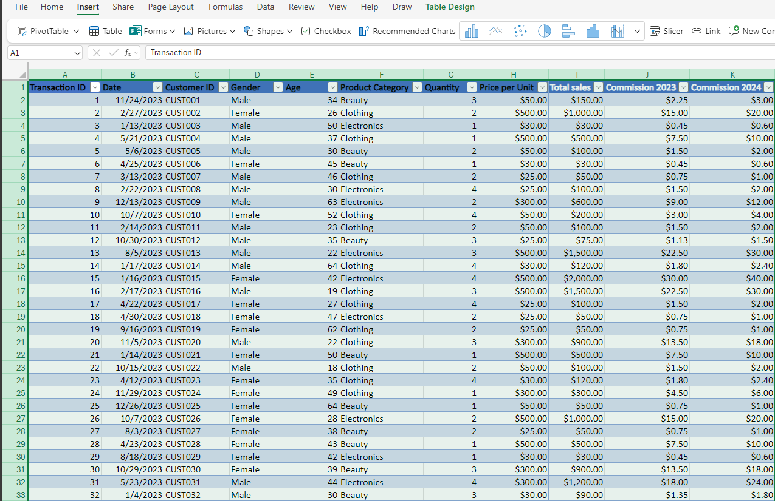
Print screen 2 | 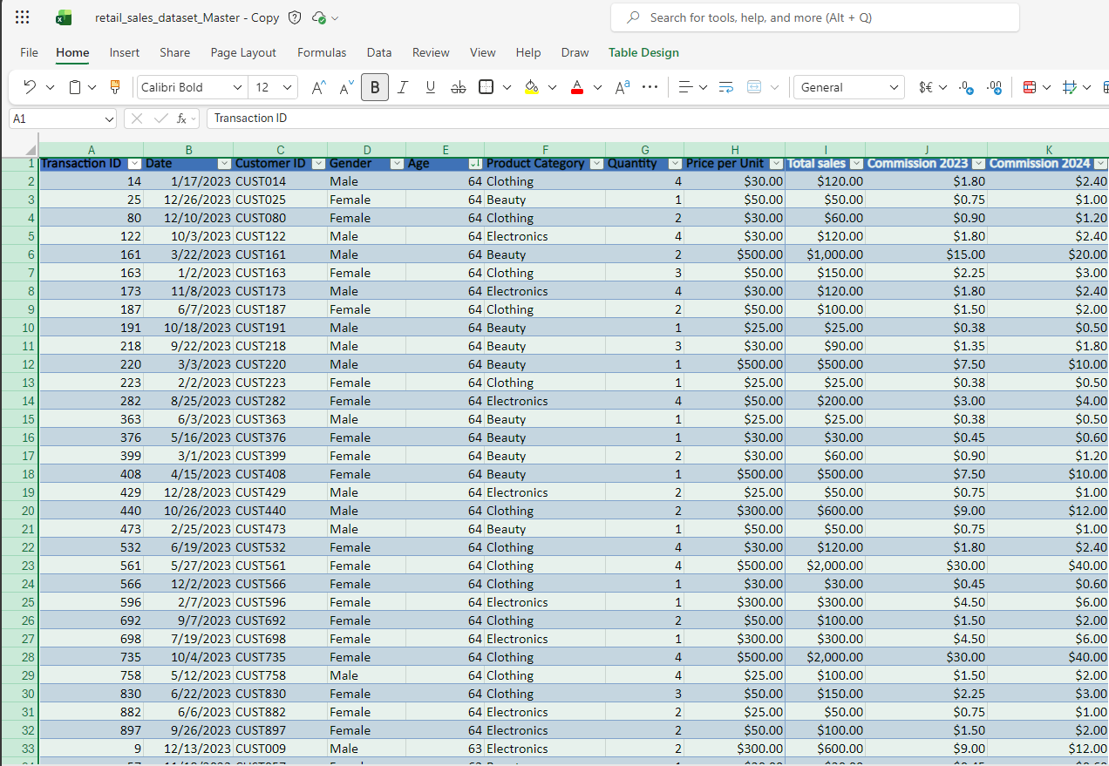
Print screen 3
Print screen 4

Day 2: Task 2

Please research and complete the following tasks within the retail-sales_dataset.xlsx document, paste print screens into the provided box below:

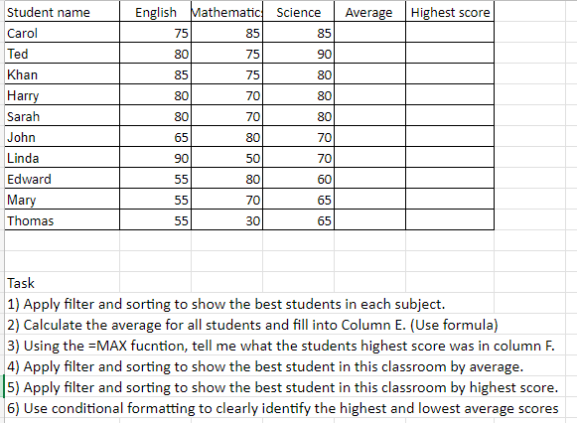

Print screen 1 | 1.  2.  3.  4.5.6.

Day 2: Task 3

Using the skills developed today, have some fun with the data set you have imported. Paste your work below and enjoy!

Print screen 1 | I added average_score and midterm_grade and used conditional formatting

Day 3: Task 1

Please download the dataset ‘Day_3_Task_1_Bike_Sales_Pivot_Lab.xlsx’ and the lab instructions.

Do not worry if you do not complete the lab, just working with data and playing with the pivot table will be good experience.

Please paste your final pivot table below and complete the reflection questions:

Print screen 1
In which markets does Germany have customers? | Male & Female Adults (35-64)
What country has sales in all markets? | Australia
What are the most profitable markets by country, age group, and gender? | Most profitable market by country: Australia  Most profitable market by age group: Adults (35-64)  Most profitable market by gender: Female
Any other findings?

Day 3: Task 2

The dataset below tracks the sales performance of different products in various counties in England. Please paste the dataset into a blank Excel workbook. Your task is to:
- Create a Pivot Table to summarise the data by county and product.
- Use the SWITCH function to categorise products based on their sales volume.

Dataset:
County | Product | Sales Volume
Yorkshire | Laptops | 500
Yorkshire | Smartphones | 200
Cornwall | Laptops | 700
Cornwall | Printers | 400
Lancashire | Smartphones | 150
Lancashire | Laptops | 600
Essex | Printers | 800
Essex | Smartphones | 300
Durham | Laptops | 250
Durham | Printers | 300
Greater Manchester | Smartphones | 600
Greater Manchester | Laptops | 400

Step 1: Create a Pivot Table
- Select the dataset (columns A to C).
- Insert a Pivot Table to summarise the data by County in the rows and Products in the columns. Use Sales Volume as the value to be summarised.

Step 2: Use the SWITCH Function
In a new column next to your data, use the SWITCH function to categorise products based on Sales Volume as follows:
  - For sales greater than 600: "High"
  - For sales between 300 and 600: "Medium"
  - For sales less than 300: "Low"
SWITCH Function Example:
=SWITCH(TRUE, C2 > 600, "High", C2 >= 300, "Medium", "Low")
- Apply this formula to each row, and check if the products are categorised correctly.

Submission:
- A completed Pivot Table summarising sales by county and product.
- A new column in the dataset categorising products by sales volume using the SWITCH function.
  - Please paste your completed work below

Print screen 1

Day 3: Task 3

Please download the dataset ‘Day_3_Task_3_Bike_Sales_Visualisations_Lab.xlsx’ and the the lab instructions. Do not worry if you do not complete the lab, just working with data and playing with the charts will be good experience.

Please paste your results below:

Print screen 1

Day 4: Task 1

You have been asked to deliver your analysis findings to the board of directors, with your analysis you have identified that customers are leaving your company at the 12-month point, this is typically when they receive their renewal price.

Conduct research and complete the below questions:

How would you prepare for the delivery? | I would prepare in four stages.  Firstly, understand the audience. I would focus on risk, impact and decisions and anticipate questions around revenue and pricing strategy.  Then I would validate the insights by double checking all data and present segmented results (e.g. by product, region and customer type) to ensure the pattern is real and not misleading/anecdotal.  Thirdly, I would define the objective. The goal of this delivery is not only to inform but get approval for change in pricing, communication and / or a retention strategy.  Finally, I would rehearse by practising explaining the insights in plain business language and by preparing concise answers to likely questions from the board.
What tools would you use for the delivery? | The tools I would use:  PowerPoint, it’s structured, familiar and board friendly.  Excel (PivotTables & charts) would be used to validate analysis.
What is prospecting and why would you complete this before your delivery? | Prospecting is the process of identifying and contacting potential customers to generate new business. It would involve understanding the board’s priorities and decision-making criteria before delivering the analysis, ensuring the message is relevant and persuasive.  This would be done before delivery to ensure analysis and recommendations are aligned with customer needs, behaviour and expectations as well as market realities. This process allows recommendations presented to the board to be relevant, evidence-based, and commercially effective.
Tell me best practices for public speaking and providing updates to senior leaders | Knowing your audience is the most important practice for public speaking and providing updates to senior leaders. They care about outcomes, risks and decisions so technical detail should be avoided unless asked.  Being honest and evidence based is also crucial. Backing claims with data is imperative as well as knowing limitations. This practice builds credibility with board members.
What will you show the board in your delivery? | In my delivery, I would only show what supports decision making. I would start with my key findings; in this case it would be clear evidence that customers are leaving the company at the 12-month renewal point.  My next step would be to visualise this with a simple chart.  Then I would focus on business impact i.e. estimated revenue loss due to customers leaving.  My next focus would be the root cause, this could be a renewal price increase, timing of communication for renewal and / or offers from competitors.  Finally, I would offer 2-3 realistic recommendations.
How will you articulate the changes that are needed? | I would use a problem, impact, solution structure:  - Problem: Customers leave when they recieve their renewal price  - Impact: Loss of revenue, reduced lifetime value  - Solution: Review renewal pricing strategy, improve communication timing and messaging and / or introduce retention incentives and strategies before month 12
Provide a list of online resources and videos that will support your preparation for public speaking | Websites and platforms:  - TED Talks  - MindTools  - Harvard Business Review  YouTube videos:  - Build Executive-Ready Presentations by Dan Galletta  - How to Develop Executive Gravitas by The CEO Project  - Telling Stories with Data in 3 Steps (Quick Study) by Havard Business Review
Evaluate tools that provide visualisation.

Tell me what they are.

Tell me what you would choose when delivering your presentation and why

Course Notes

It is recommended to take notes from the course, use the space below to do so, or use the revision guide shared with the class:

Additional Information

We have included a range of additional links to further resources and information that you may find useful, these can be found within your revision guide.

END OF WORKBOOK

Please check through your work thoroughly before submitting and update the table of contents if required.

Please send your completed work booklet to your trainer.

